Inside the AI Agent: Loop Engineering, Memory, and RAG

In the first part of this series, we learned that an AI Agent is more than an LLM. An agent combines an LLM with tools, memory, knowledge, planning, actions, feedback, and an agent harness.
But an important question remains:
How does an AI Agent actually work through a complex task?
The answer lies in three important concepts:
- Agent Loops
- Memory Systems
- Retrieval-Augmented Generation (RAG)
Together, these components allow an agent to work iteratively rather than simply generating one response and stopping.

The Agent Loop
A traditional LLM interaction often looks like:
Prompt → LLM → Response
An agent follows a more dynamic process:
Goal → Plan → Action → Observation → Reasoning → Action → Observation → Evaluation
The important difference is that the agent can continue working after its first action.
For example, imagine asking:
"Find research papers about AI in software engineering and identify research gaps."
The agent might:
Step 1: Understand the goal.
Step 2: Create a plan.
Step 3: Search for papers.
Step 4: Retrieve relevant documents.
Step 5: Analyze the papers.
Step 6: Compare their results.
Step 7: Determine whether enough evidence exists.
Step 8: Search again if information is missing.
Step 9: Generate the final report.
This repeated process is the agent loop.

2. Why Loop Engineering Matters
Simply creating a loop does not automatically make an agent reliable.
Imagine an agent repeatedly performing an unsuccessful action:
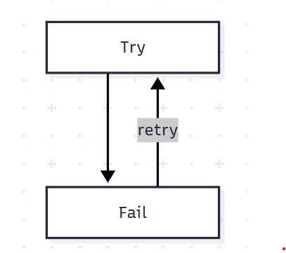
If there is no stopping mechanism, the agent could continue indefinitely.
This creates several problems:
- Excessive API usage
- High token consumption
- Increased cost
- Long execution times
- Repeated tool calls
- Unpredictable behavior
Therefore, developers need to carefully design how an agent starts, continues, and stops its execution loop. This is called Loop Engineering.

3. End-Loop Guardrails
An agent needs clear conditions that tell it when to stop.
One important mechanism is a completion criterion.
For example:
Stop when sufficient evidence has been collected and the requested report has been generated.
Another mechanism is a Human-in-the-Loop trigger.
The agent can pause and ask a human for permission when an important decision or approval is required.
So, instead of allowing unlimited autonomous execution:
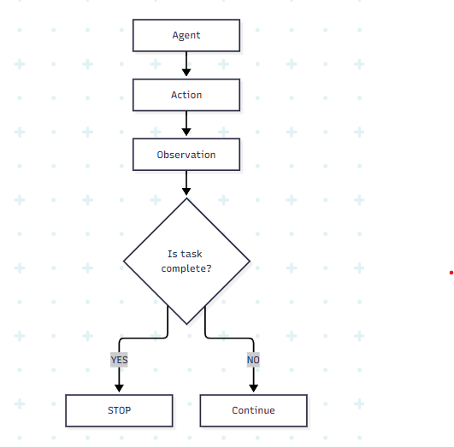
These controls make the agent's behavior more manageable.

4. Memory Systems
Another major component of an AI Agent is memory.
An agent may need information from:
- The current conversation
- Previous conversations
- Documents
- Databases
- Previous tasks
- User preferences
- Intermediate results
Memory allows the system to retain useful information rather than treating every interaction as completely isolated.

5. Short-Term Memory
Short-term memory contains information relevant to the current interaction.
For example:
User:
"My research topic is AI in software engineering."
Later the user asks:
"What research gaps should I investigate?"
The system can use the earlier information to understand what the second question refers to.
The information is useful because it provides context for the current interaction.

6. Long-Term Memory
Long-term memory stores information externally so that it can be retrieved later.
Possible storage systems include:
- Relational databases
- Document databases
- Vector databases
- Knowledge graphs
- Specialized memory stores
A simplified architecture is:
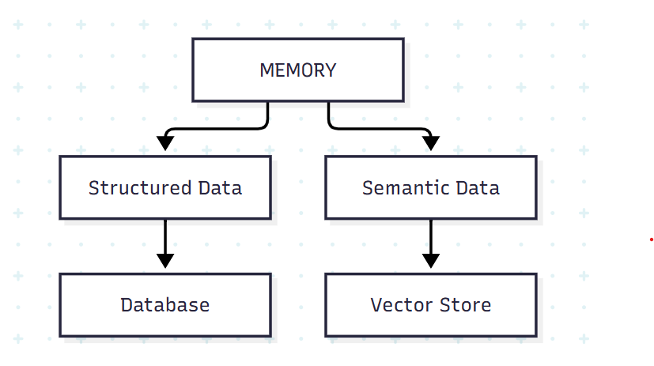
The purpose is to allow an agent to retain and retrieve useful information beyond the immediate interaction.

7. Memory Is Not the Same as RAG
This is an important distinction.
Memory and RAG are related, but they solve different problems.

Memory
Memory is primarily about retaining useful information about:
- Users
- Interactions
- Tasks
- Previous states
- Intermediate results

RAG
RAG is primarily about retrieving relevant external knowledge.
In simple terms:
Memory = Remember
RAG = Retrieve

8. What Is RAG?
RAG stands for Retrieval-Augmented Generation
Suppose you have 1,000 research papers.
You don't want to send all 1,000 papers to the LLM every time someone asks a question.
Instead, a retrieval system searches the collection and identifies the relevant documents.
he process becomes:
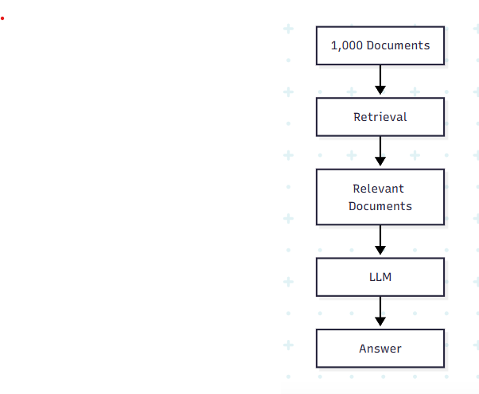
For example, suppose we ask:
"Which papers used YOLOv8 for oral cancer detection?"
The RAG system searches the document collection and retrieves relevant papers or passages.
Those retrieved materials are then provided to the LLM so that it can generate an answer based on the relevant information.

9. RAG in an AI Research Agent
Imagine building an AI research assistant.
The user asks:
"Analyze recent research on AI across the Software Development Life Cycle."
The agent might perform:
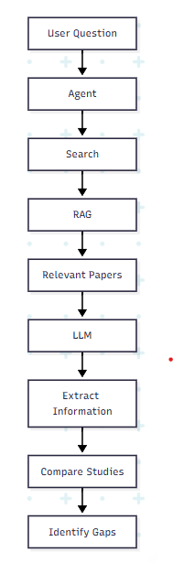
The important point is that the LLM does not need to know everything beforehand.
The system can retrieve relevant information and provide it to the LLM when needed.

10. Putting the Three Concepts Together
We can now understand the relationship between Loop, Memory, and RAG.

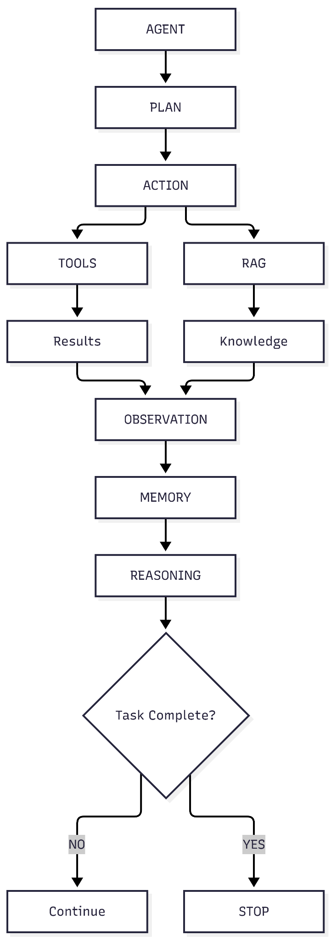
The loop determines how the agent continues working. An AI Agent becomes powerful because it can operate iteratively.The Agent Loop allows it to take multiple actions. Loop Engineering prevents uncontrolled execution.

Memory determines what information the agent can retain. Memory allows it to retain useful information.
RAG determines what external knowledge the agent can retrieve.

RAG allows it to retrieve relevant external knowledge.
Together, these components transform an LLM from a system that simply responds to prompts into a system that can work through complex tasks.
But building the agent is only half of the challenge.
Once the agent is deployed, we need to answer another question:
How do we monitor, evaluate, debug, and continuously improve it?
That brings us to LLMOps.

